Grade 7 Accelerated · Unit 4 · Lesson 4  Real-World Problems and Significant Digits  Question Bank - Additional 4.04 | Name______________________  Date______________________  Period____________________

Show your work. Circle your final answer.
For questions 1 through 4, give the number of significant digits in each measurement.
1. 9,304 kilograms

2. 0.00062 meters

3. 1.500 seconds

4. 430,000 litres

For questions 5 through 8, solve. Report each answer with the correct precision.
5. A rectangular field measures 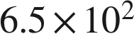 m by 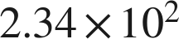 m. Find its area.

6. A train travels 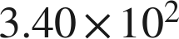 km in 4.0 hours. Find its average speed.

7. Two lengths are measured: 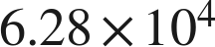 mm and 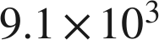 mm. Find their sum.

8. Two masses are measured: 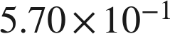 g and 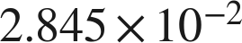 g. Find their difference.

Real quantities.
9. A wind turbine generates about 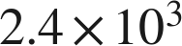 kilowatt-hours of electricity each hour.
a. How much does it generate in 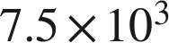 hours? Report the answer with the correct number of significant digits.

b. A second turbine generates about 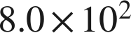 kilowatt-hours each hour. How many times larger is the first turbine's rate? Report the answer with the correct number of significant digits.

10. A sensor records about 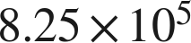 readings each second.
a. How many readings does it record in one minute? Report the answer with the correct number of significant digits.

b. Four of these sensors run for 30 minutes. How many readings do they record altogether? Report the answer with the correct number of significant digits.

Reading someone else's work.
11. Bianca adds two measured lengths, 86.4 cm and 0.271 cm. She says that because 86.4 has three significant digits and 0.271 has three, the sum has three: 86.7 cm. Is she right? Explain, and give the correct sum.

12. A rectangle's sides are measured as 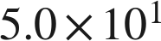 cm and 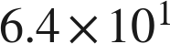 cm. Which is the area, in scientific notation with the correct number of significant digits?
○ A. 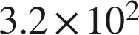 cm²
○ B. 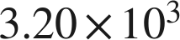 cm²
○ C. 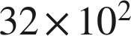 cm²
○ D. 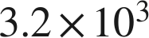 cm²

